COURIER DELIVERY DASHBOARD
MODEL
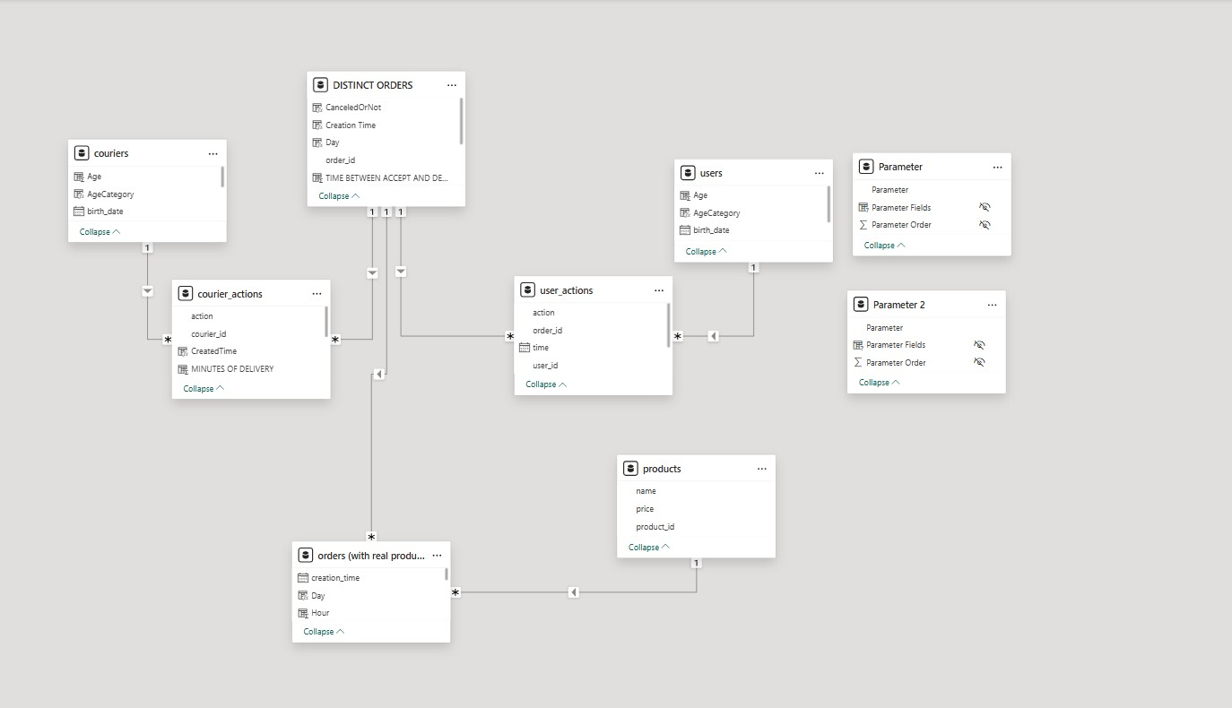


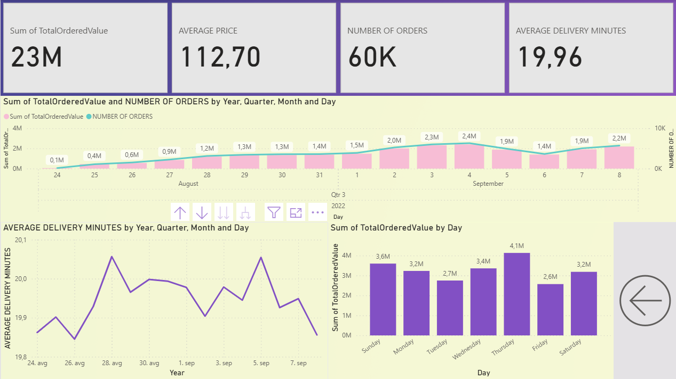
📊 General Performance Overview
- Total Ordered Value: 23 million
- Average Order Price: 112.70
- Number of Orders: 60,000
- Average Delivery Time: 19.96 minutes

📈 Trends Over Time (August 24 – September 8)
- There is a steady increase in both total order value and number of orders from August 24 to early September.
- Peak values were recorded on September 4 with a total order value of 2.4M.
- A drop in performance is visible around September 5 and 6, with both order value and number of orders decreasing.
- Recovery begins again on September 7–8, showing upward movement.

🕒 Average Delivery Minutes
- Delivery time remained relatively stable, averaging close to 20 minutes.
- Slight fluctuations are visible, with the highest delivery time around August 28 and September 3, but differences are marginal (~0.2 minutes).

📅 Performance by Day of Week
- Best-performing day: Thursday, with the highest order value of 4.1M.
- Sunday also shows strong performance (3.6M), despite typically being a lower-activity day in many industries.
- Friday has the lowest order value (2.6M), indicating potential for improvement in weekend operations.
- Overall, the business performs well throughout the week, with balanced order distribution.

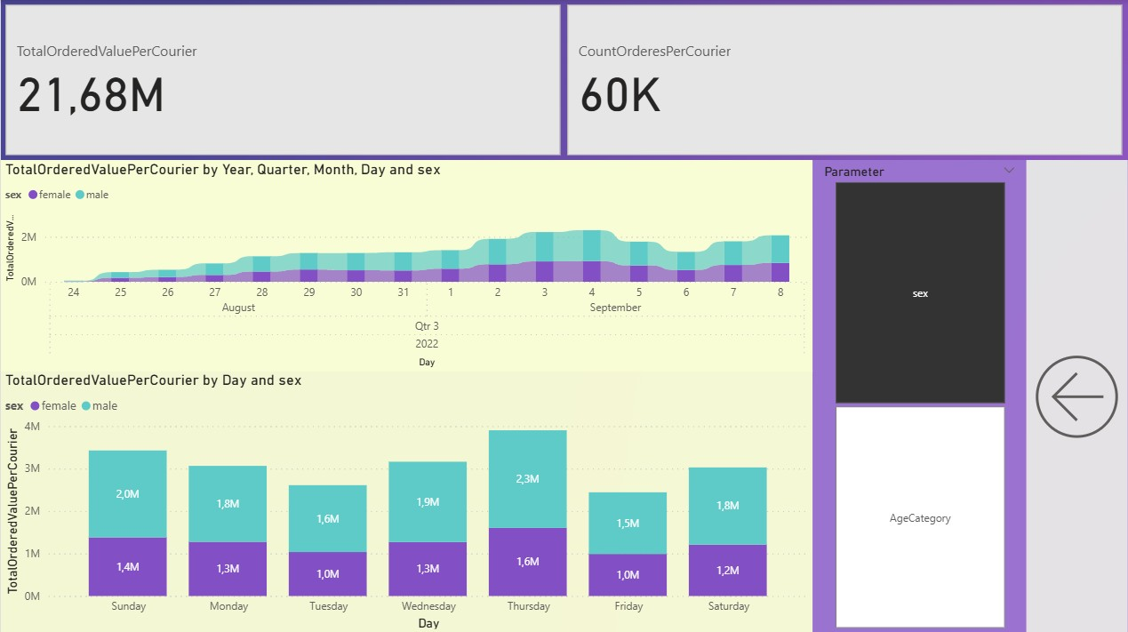
📆 Trend Over Time (Aug 24 – Sep 8) by Gender
- Both male (blue) and female (purple) couriers show a steady increase in delivery value over time.
- Male couriers consistently contribute a larger share of the total delivery value throughout the period.
- The gap between male and female couriers remains stable, suggesting consistent performance patterns.

📅 Total Ordered Value by Day and Gender
- Male couriers deliver a higher total value across all days of the week.
- The highest performing day is Thursday:
  - Male couriers: 2.3M
  - Female couriers: 1.6M
- Lowest performing day for both genders: Friday
  - Male: 1.5M
  - Female: 1.0M
- The most balanced day in terms of contribution is Monday (Male: 1.8M, Female: 1.3M).

🟣🔵 Gender Distribution Insights
- Male couriers consistently outperform female couriers in terms of total order value, suggesting higher delivery volume, longer routes, or higher-value orders.
- Female courier contribution remains steady, indicating reliability and consistency despite the volume difference.

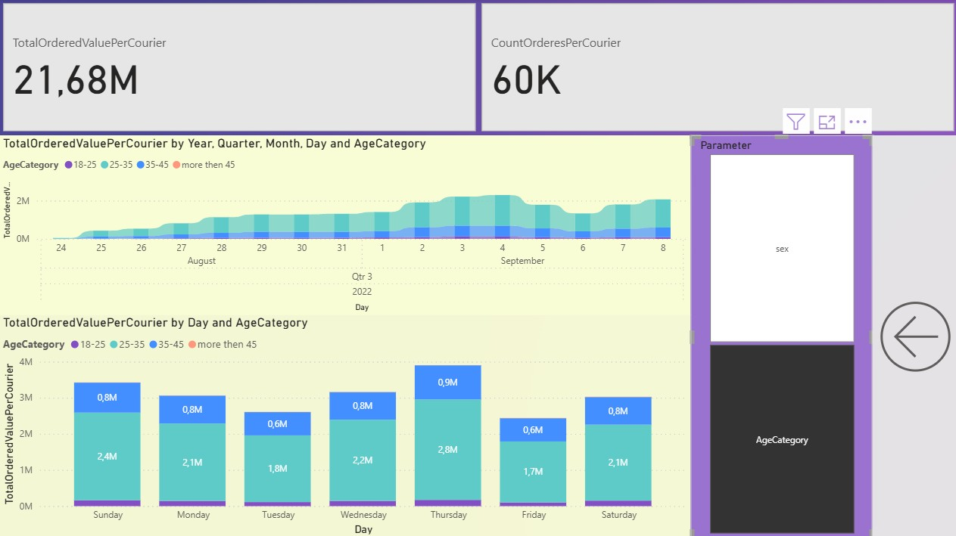
📆 Trends Over Time (Aug 24 – Sep 8)
- The 25–35 age group (light blue) is the dominant contributor to total order value every day.
- The 35–45 age group (blue) also contributes significantly but less than the 25–35 group.
- Couriers aged 18–25 and over 45 contribute much less, almost negligible in total share.
- All age groups show a stable or slightly increasing trend in performance over the analyzed period.

📅 Performance by Day and Age Group
- The 25–35 age group consistently delivers above 2M in value across most days, peaking at 2.8M on Thursday.
- The 35–45 group contributes between 0.6M and 0.9M per day, also peaking on Thursday.
- Minimal contribution from couriers under 25 and over 45, indicating lower involvement or volume.
- Thursday and Sunday are again the highest-performing days, aligning with previous dashboards.

✅ Key Insights
- Couriers aged 25–35 are the core workforce, responsible for the bulk of delivery value.
- The 35–45 group plays a secondary but still significant role.
- Younger (18–25) and older (>45) couriers may need more support, training, or may work fewer hours or lower-value routes.
- Performance is highest mid to late week, especially Thursday, suggesting this is a peak demand day.

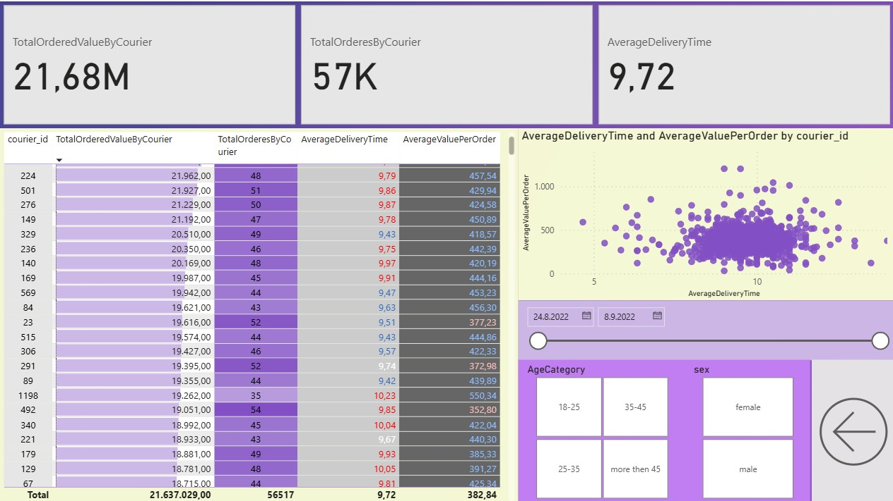

📈 Scatter Plot: Delivery Time vs. Delivered Value per Order
- Most couriers are clustered between 350–500 in delivered value per order and 8–10 min delivery time.
- There’s a positive trend: couriers who deliver higher-value orders often require slightly longer times, likely due to order size, complexity, or delivery distance.
- There's no extreme inefficiency — even those with high delivery times tend to compensate with high-value orders.

🧠 Refined Conclusions
- The delivered value per order is a strong metric of courier productivity — and overall, it is high, averaging nearly 383 per order.
- Top-performing couriers are not only fast but also handle high-value deliveries, showing good resource allocation.
- Slightly longer delivery times can be acceptable if the delivered value justifies it.
- Courier performance evaluation should focus on balance: minimizing delivery time without compromising delivered value.

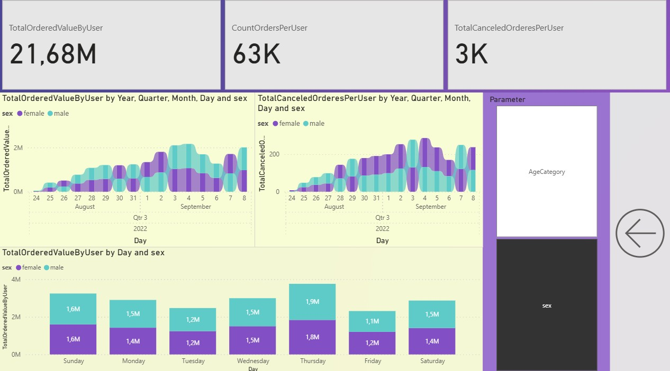

1. Balanced Spending Between Genders
- Both female and male users contributed almost equally to the total ordered value.
  - Example: On Sunday, each gender contributed 1.6M to the total.
- This suggests that marketing and engagement strategies are equally effective across genders.
2. Peak Activity on Thursdays
- The highest total ordered value occurred on Thursdays (1.9M males, 1.8M females).
- Indicates Thursday is the most active day for both male and female users — a potential day to:
  - Launch promotions
  - Send targeted marketing
  - Test new features
3. Order Cancellations by Gender
- Canceled orders show no significant gender imbalance, but the volume of cancellations increased steadily until around September 4.
- After that, cancellation rates dropped — possibly due to:
  - Operational improvements
  - Policy changes
  - External factors (weather, demand changes, etc.)
4. Daily Trends
- User activity increased steadily in late August and peaked in early September.
- Similar growth trends were observed for both order value and cancellations, indicating that cancellation rates scaled with volume rather than indicating dissatisfaction.

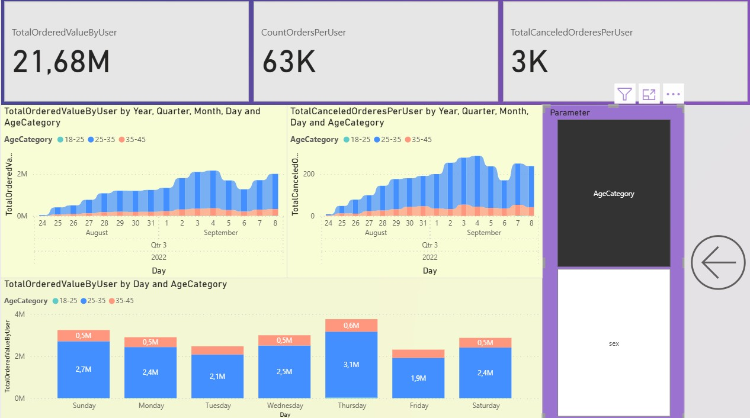

📊 Key Conclusions by Age Category
1. Dominant Age Group: 25–35
- The 25–35 age group clearly dominates both in:
  - Total order value
  - Order cancellations
- For example, on Sunday, they contributed 2.7M, compared to 0.5M from the 35–45 group.
- This group is the most active and valuable user base, making them a primary target for campaigns.
2. Stable Activity from Other Age Groups
- Users aged 35–45 show consistent but lower engagement (around 0.5M per day).
- Very minimal contribution is visible from the 18–25 group.
  - Indicates lower engagement or possibly untapped market potential.
3. Peak Day: Thursday
- Highest total value from all age groups occurs on Thursdays (total over 3.7M, with 3.1M from 25–35).
- This aligns with gender analysis and courier dashboards — Thursday is the most commercially active day.
4. Cancellations Mirror Orders
- Cancellation trends mirror the ordering trends.
  - Majority of cancellations also come from the 25–35 group, but this likely reflects their higher volume.
- No age group shows unusual cancellation behavior that would suggest dissatisfaction.

📌 Insights & Recommendations
- Focus promotional and retention efforts on the 25–35 age group, especially around Thursdays.
- Consider strategies to increase engagement among 18–25-year-olds (student discounts, trend-based campaigns, social media).
- Since cancellation patterns follow order volume, there is no major concern related to age-specific dissatisfaction.

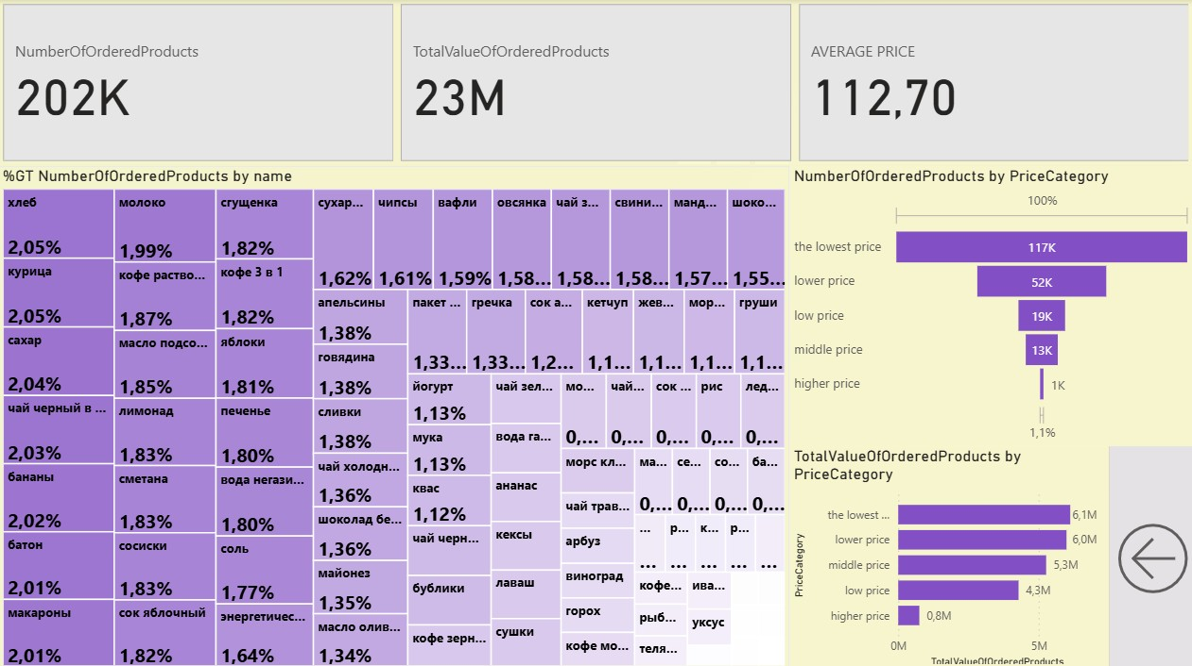

🧩 Product Popularity (Tree Map)
- The tree map shows the share of each product in total ordered quantity.
- Top products by order share (~2% each) include:
  - Bread (хлеб)
  - Chicken (курица)
  - Sugar (сахар)
  - Black tea (чай черный)
  - Bananas (бананы)
  - Milk (молоко)
  - Condensed milk (сгущенка)
  - Instant coffee (кофе растворимый)
This highlights basic staples and common grocery items as most ordered.

💰 Price Category Distribution
- Number of Products Ordered per Price Category:
  - The majority (117K) of ordered products fall into the lowest price category.
  - The lower price category has 52K ordered products.
  - Very few products in higher price categories.
- Total Value by Price Category:
  - Despite the volume in lowest categories, value is more evenly spread with:
    - ~6.1M in the lowest price category
    - ~6.0M in the lower price category
    - ~5.3M in the middle price category
    - ~0.8M in higher price categories

🔍 Insights & Recommendations
- Customers mainly purchase low-cost staple goods in large volumes.
- Value distribution suggests that middle-priced items contribute significantly despite smaller volumes.
- Focus promotions on staples like bread, chicken, milk, and sugar for volume sales.
- Explore marketing strategies to increase sales of mid- and higher-priced items for better margins.
- Keep pricing competitive in lowest and lower price categories to maintain order volume.

